

Dr. Jillian, Moran inc.
2016-12-23
Dr. Moran
87901 Amy Bypass Apt. 739, Port Lauraton, TX 21901
Phone: 6207540844
Fax: 6214508894

Re: Ashley, Roberts
PHN: 4638438263
Birthdate: 19-Dec-1975
Address: 499 Davis Field, New Erik, PR 71402
Patient number: 5551204839

To Whom It May Concern:

This is a medical letter to state the above patient is pregnant with expected delivery date of 26-Jul-2025. Hoping this information is satisfactory for your requirements.

Thank you.

Sincerely,
Dr. Jillian, Moran
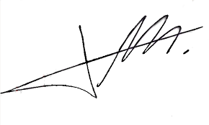
FRCS© NCMP
Clinical Assistant Professor, UBC
Department of Obstetrics and Gynecology SMH

